**SPRING BOOT APLLICATION OF CRUD**

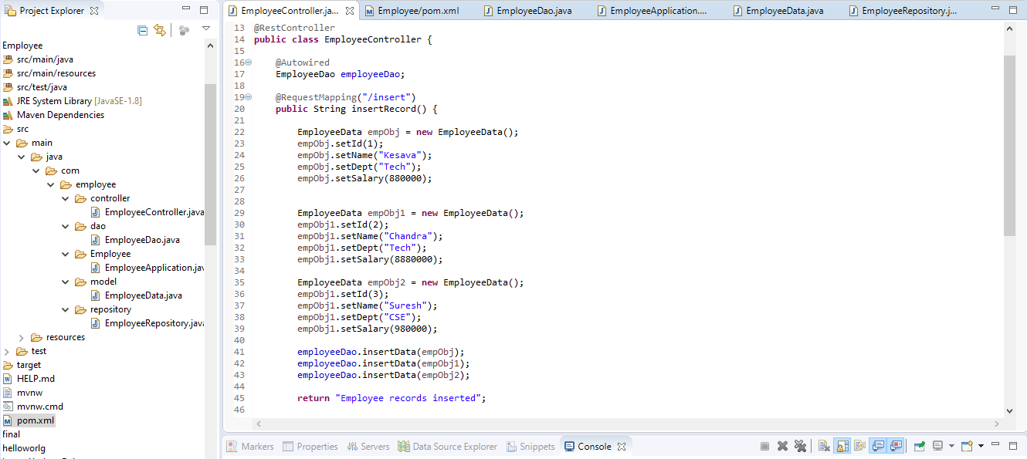

***Insert***

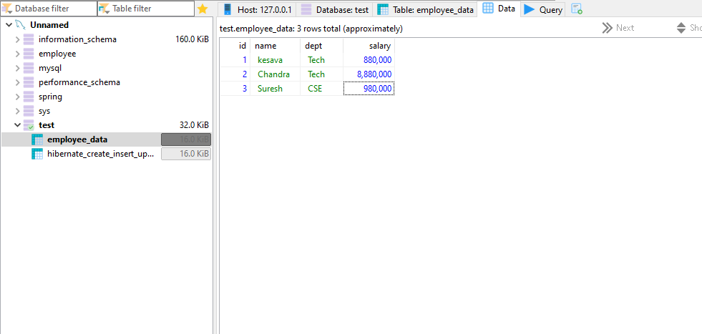

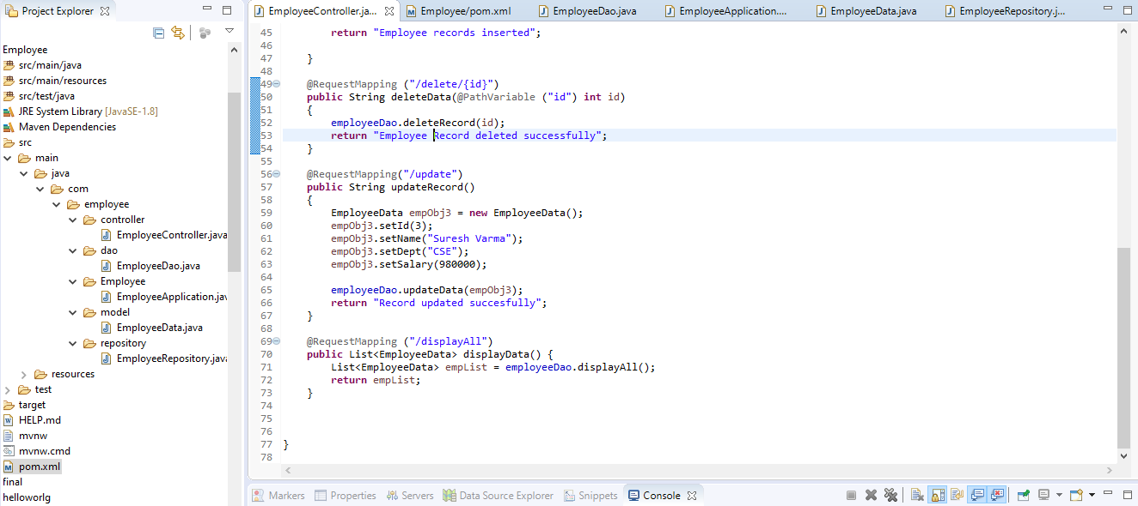

***UPDATE***

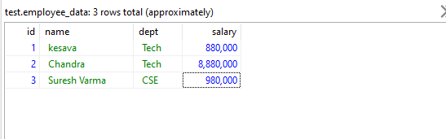

***DELETE***

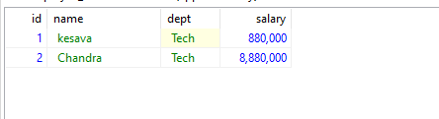

***DISPLAY INITIAL CONTENT***

